SECURITY+ V4 LAB SERIES

Lab 13: IoT Management

1 Start the Service and Create Accounts

* 1. Start ThingsBoard Service

1. Launch UbuntuSRV
2. Log in with credentials provided
3. Launch terminal
4. Enter the following command to start the ThingsBoard server:

sudo docker run -it -p 9090:9090 -p 1883:1883 -p 7070:7070 -p 5683-5688:5683-5688/udp -v ~/.mytb-data:/data -v ~/.mytb-logs:/var/log/thingsboard --name mytb --restart always thingsboard/tb-postgres

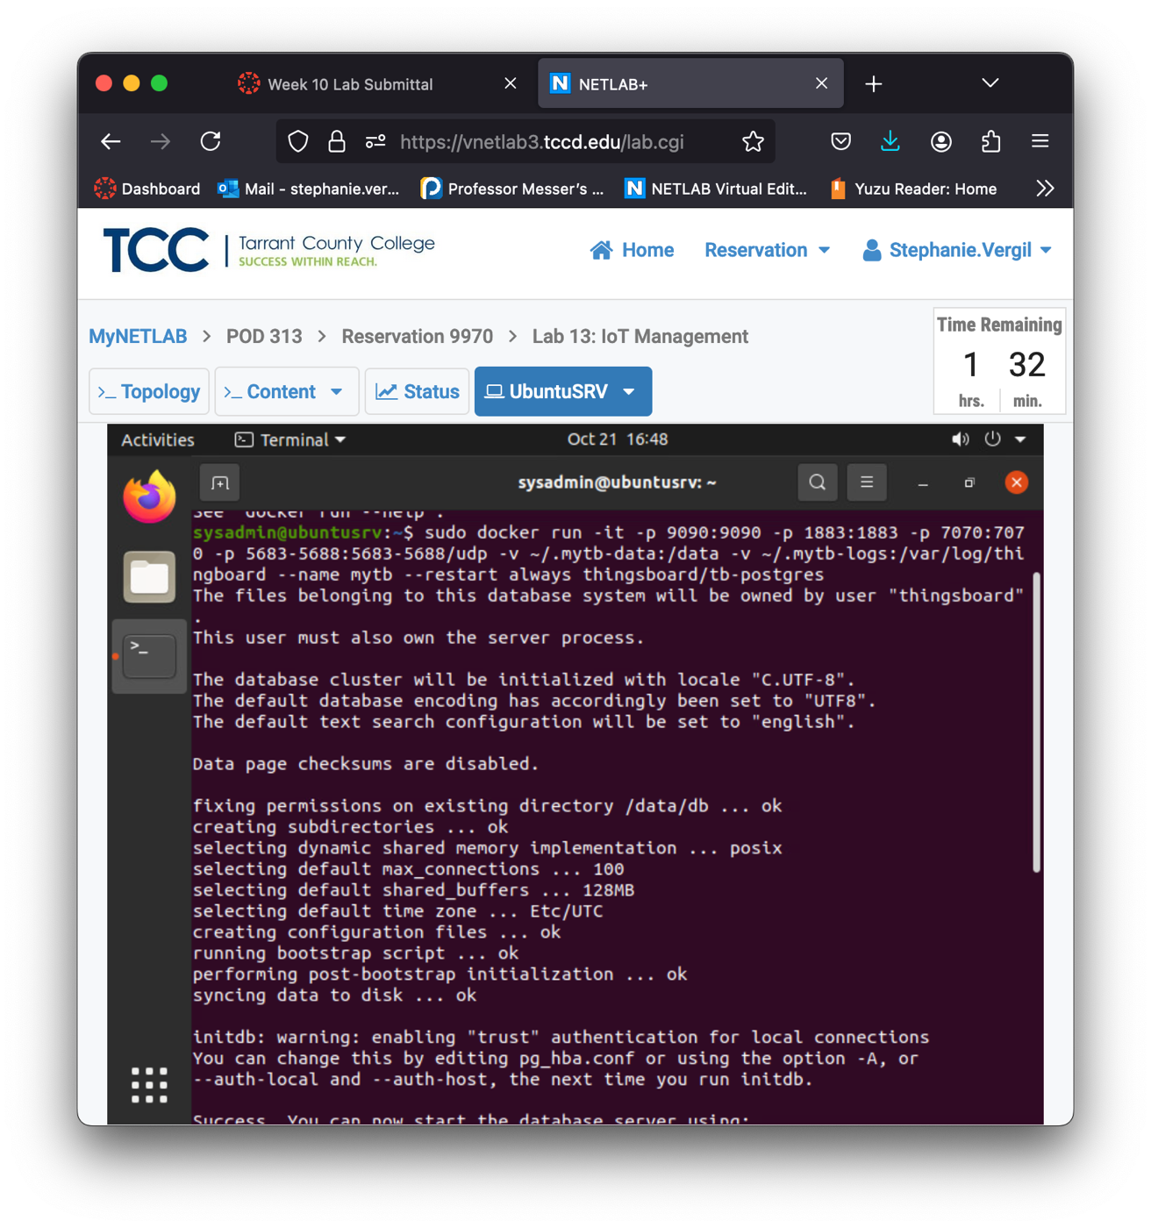

1. After a few minutes, the ThingsBoard should finish booting. You can check it by visiting the address http://localhost:9090 in a browser. When the server is ready, you should see the login below.

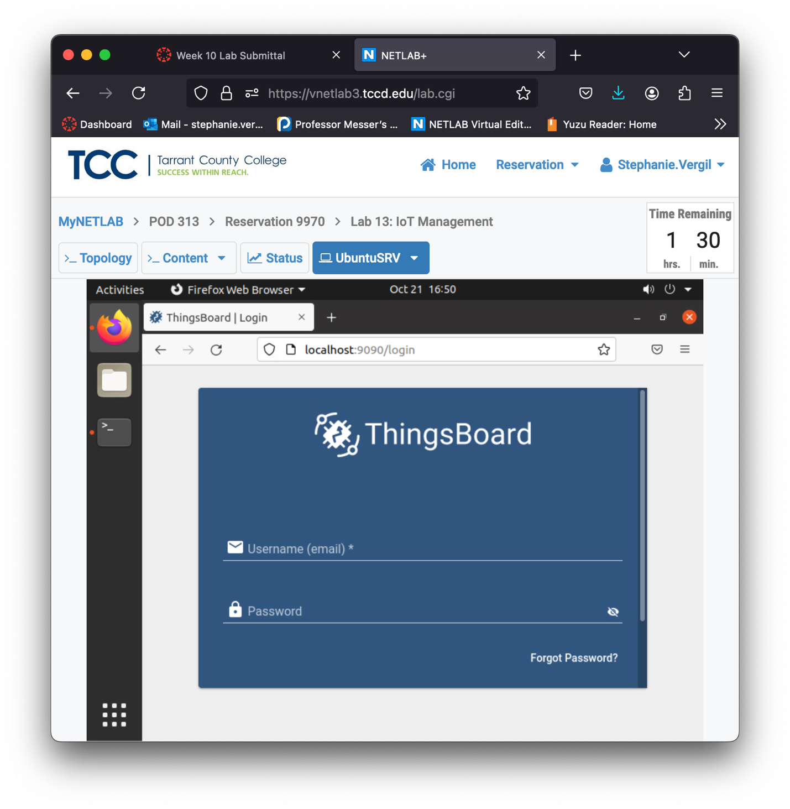

1. Fill in the default login information provided
2. Once you log in, you should see something like the image below.

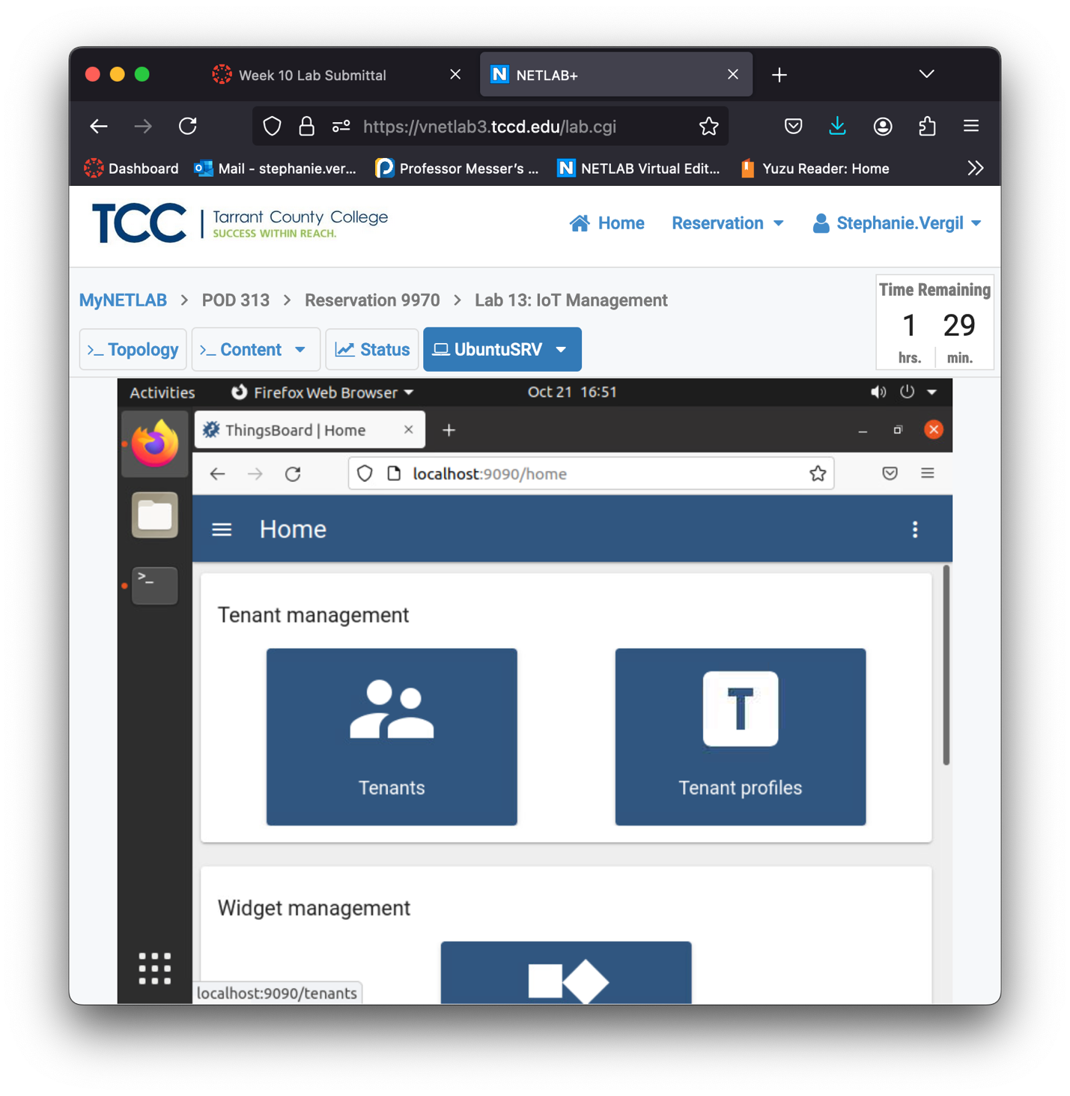

1. Click the menu button (three vertical dots) at the upper-right corner, and select Profile.
2. For security purposes, we will change the default login credentials. Click and change the Email address to sysadmin@xyzsecurity.com then click the Save button to save the change.

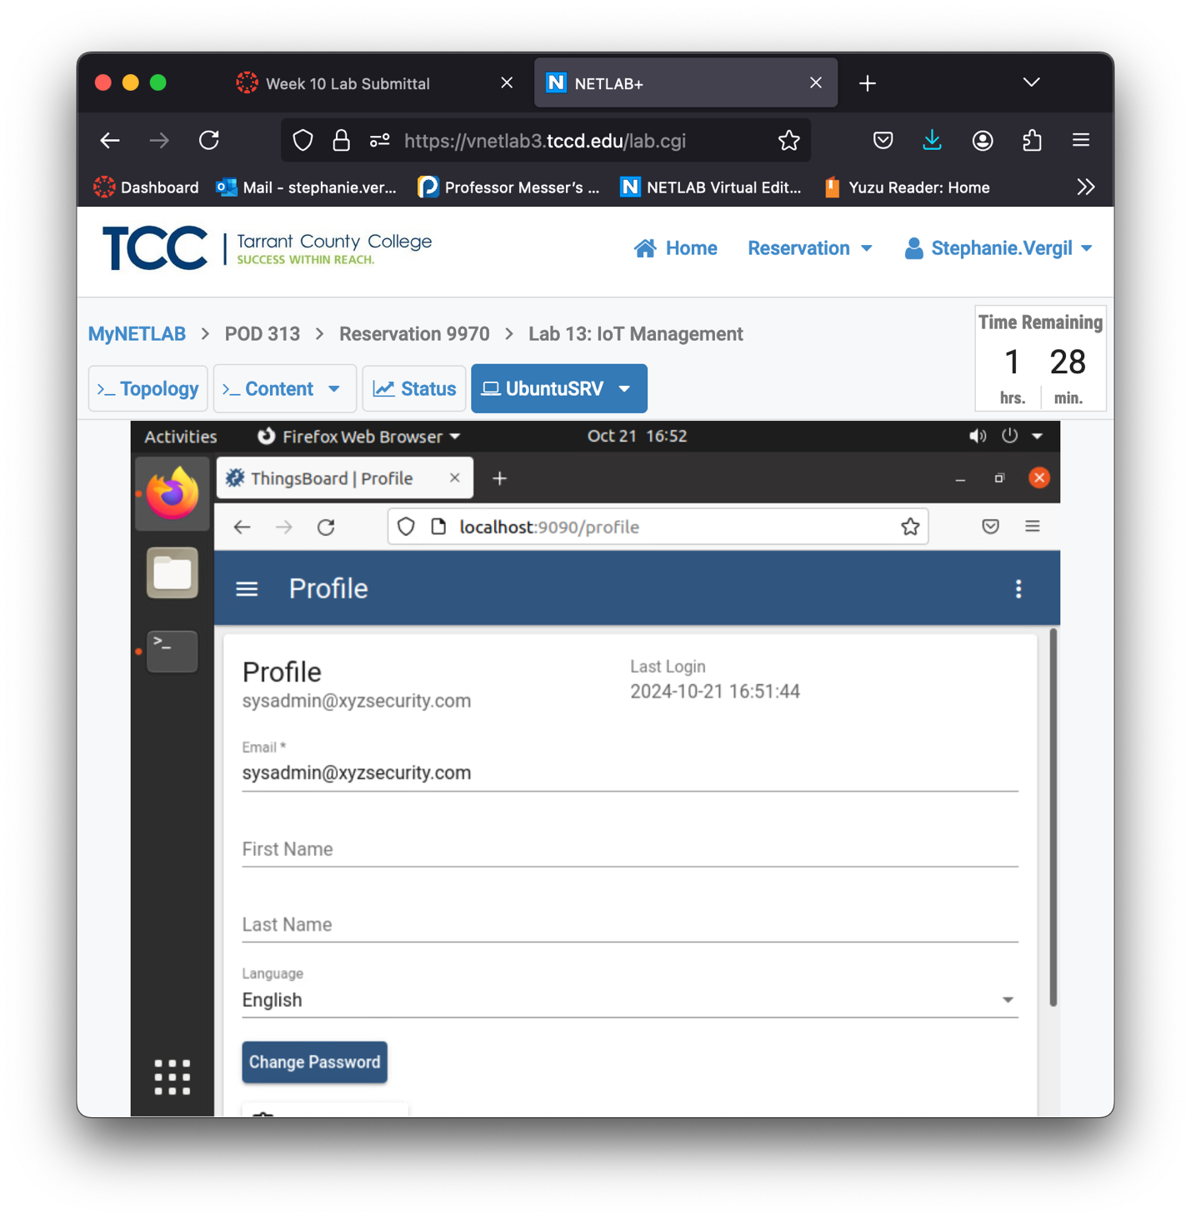

1. Then, click the Change Password button. In the pop-up window, fill in the current password sysadmin and type the new password NDGlabpass123! twice, then click Change Password to change it.

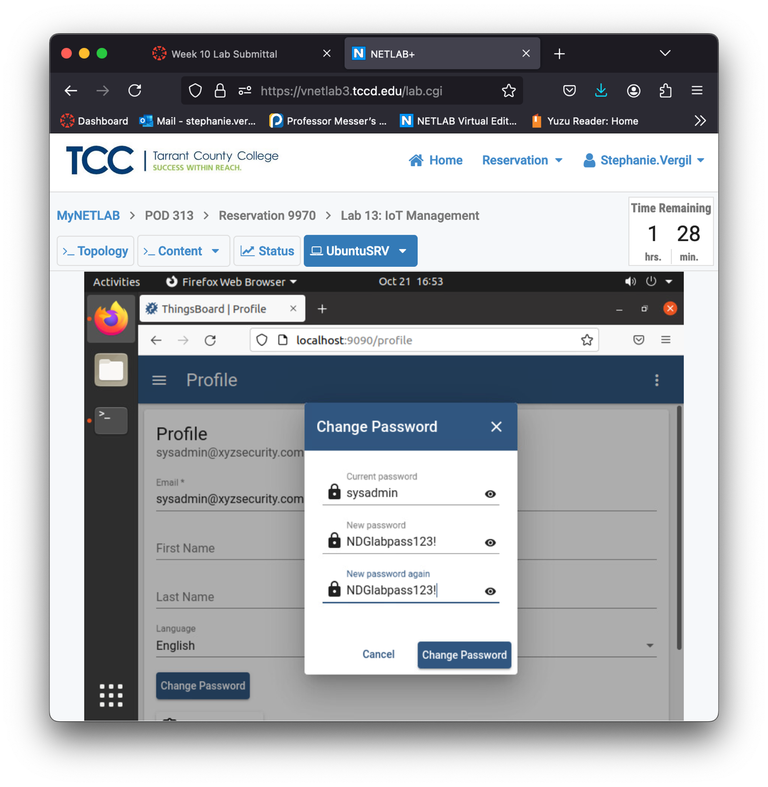

1. Once you are brought back to the Profile page, click the menu at the upper-right corner again, and click Logout to log out of the current session. Notice the user email address is already changed.
2. Log in with new credentials
   1. Create Different Accounts
3. First, we will start by creating a Tenant. Click Tenants on the left side.
4. To the right side, we will first delete the default Tenant account (again, for security purposes). Click the trash can icon.
5. A pop-up question will appear; click Yes to confirm.

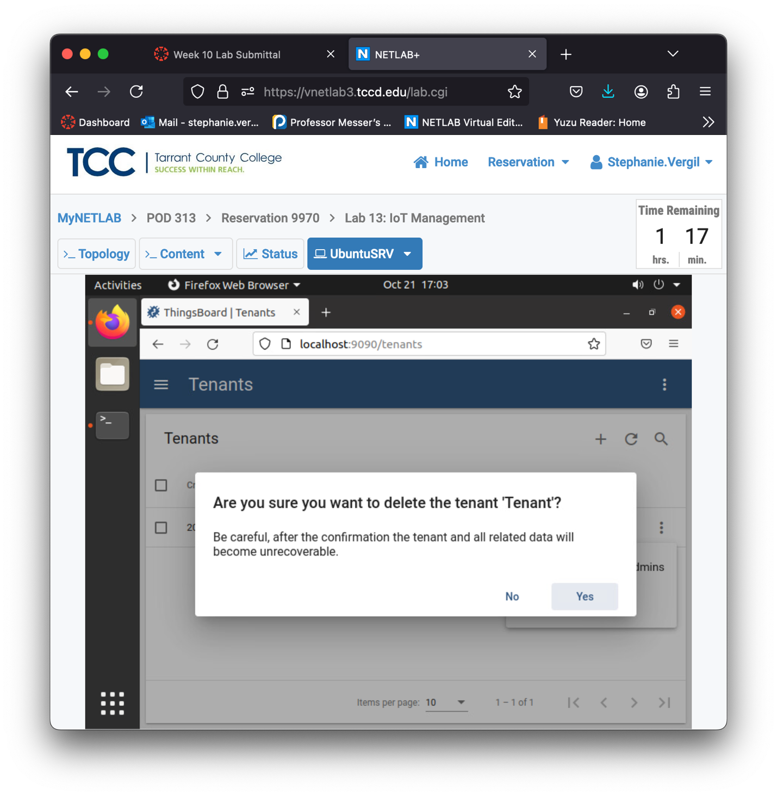

1. As the default Tenant is gone, we will create a new Tenant. Click the + button in the upper-right corner.
2. A window will pop-up. For practice purposes, we will only fill in the Title field and leave the Tenant profile as Default. Type netlab as the Title and click the Add button.

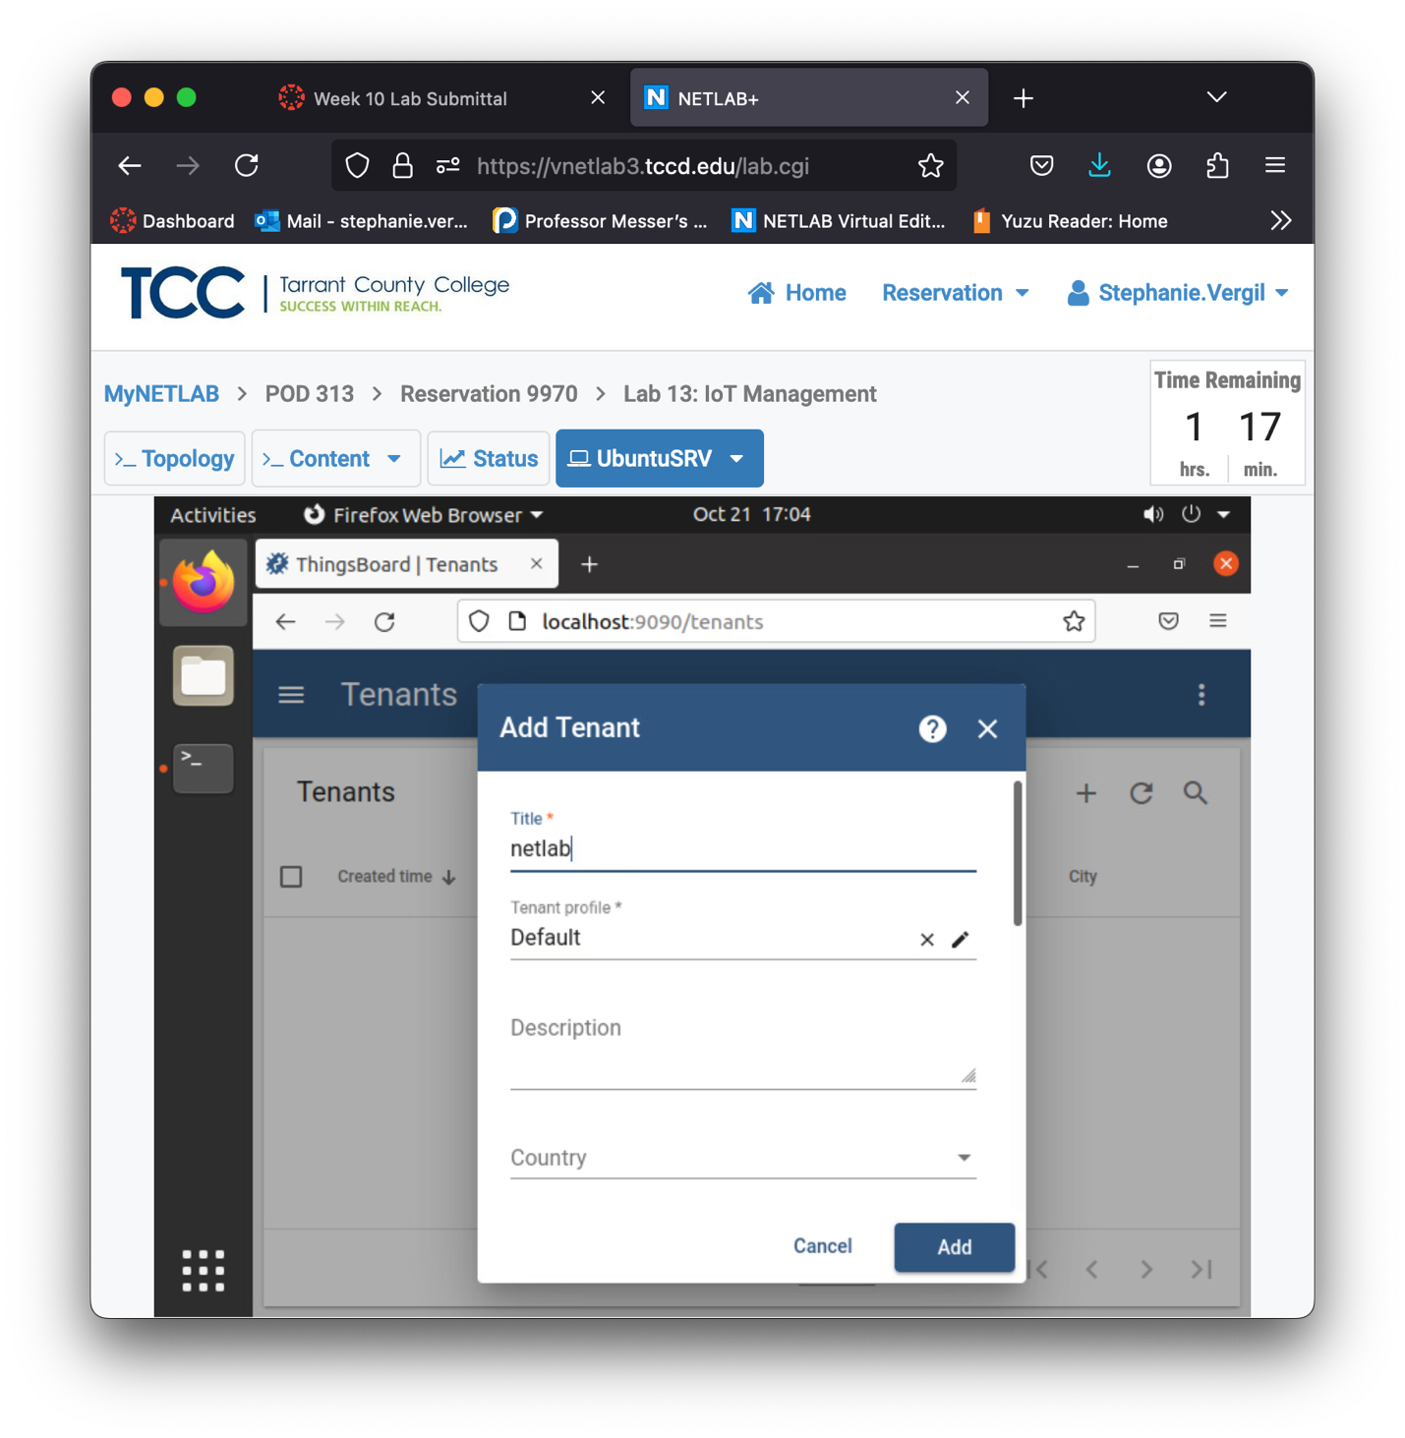

1. You should see that the netlab Tenant is created. Click the Manage tenant admins button.
2. On the new page, click the + button to create a Tenant Admin. 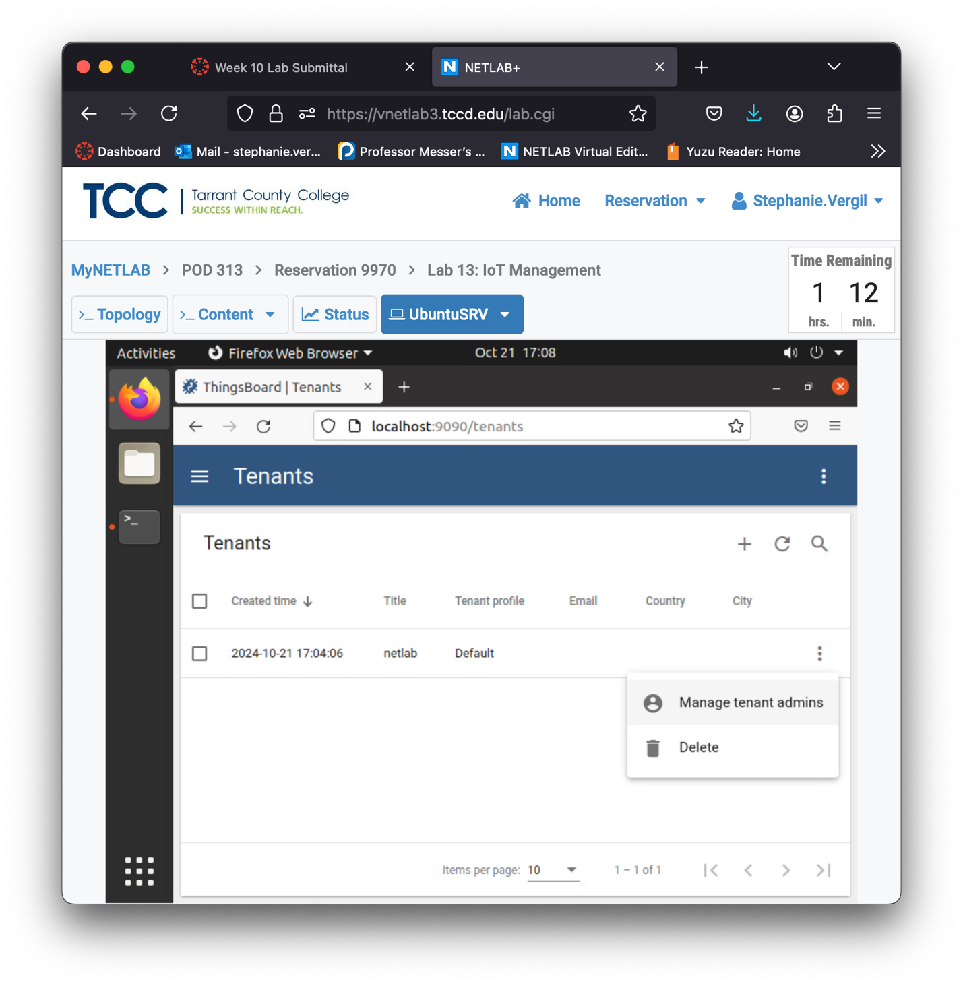
3. In the pop-up window, fill the email field as netlab_tenantadmin@xyzsecurity.com leave the Activation method as the default setting, and click the Add button.

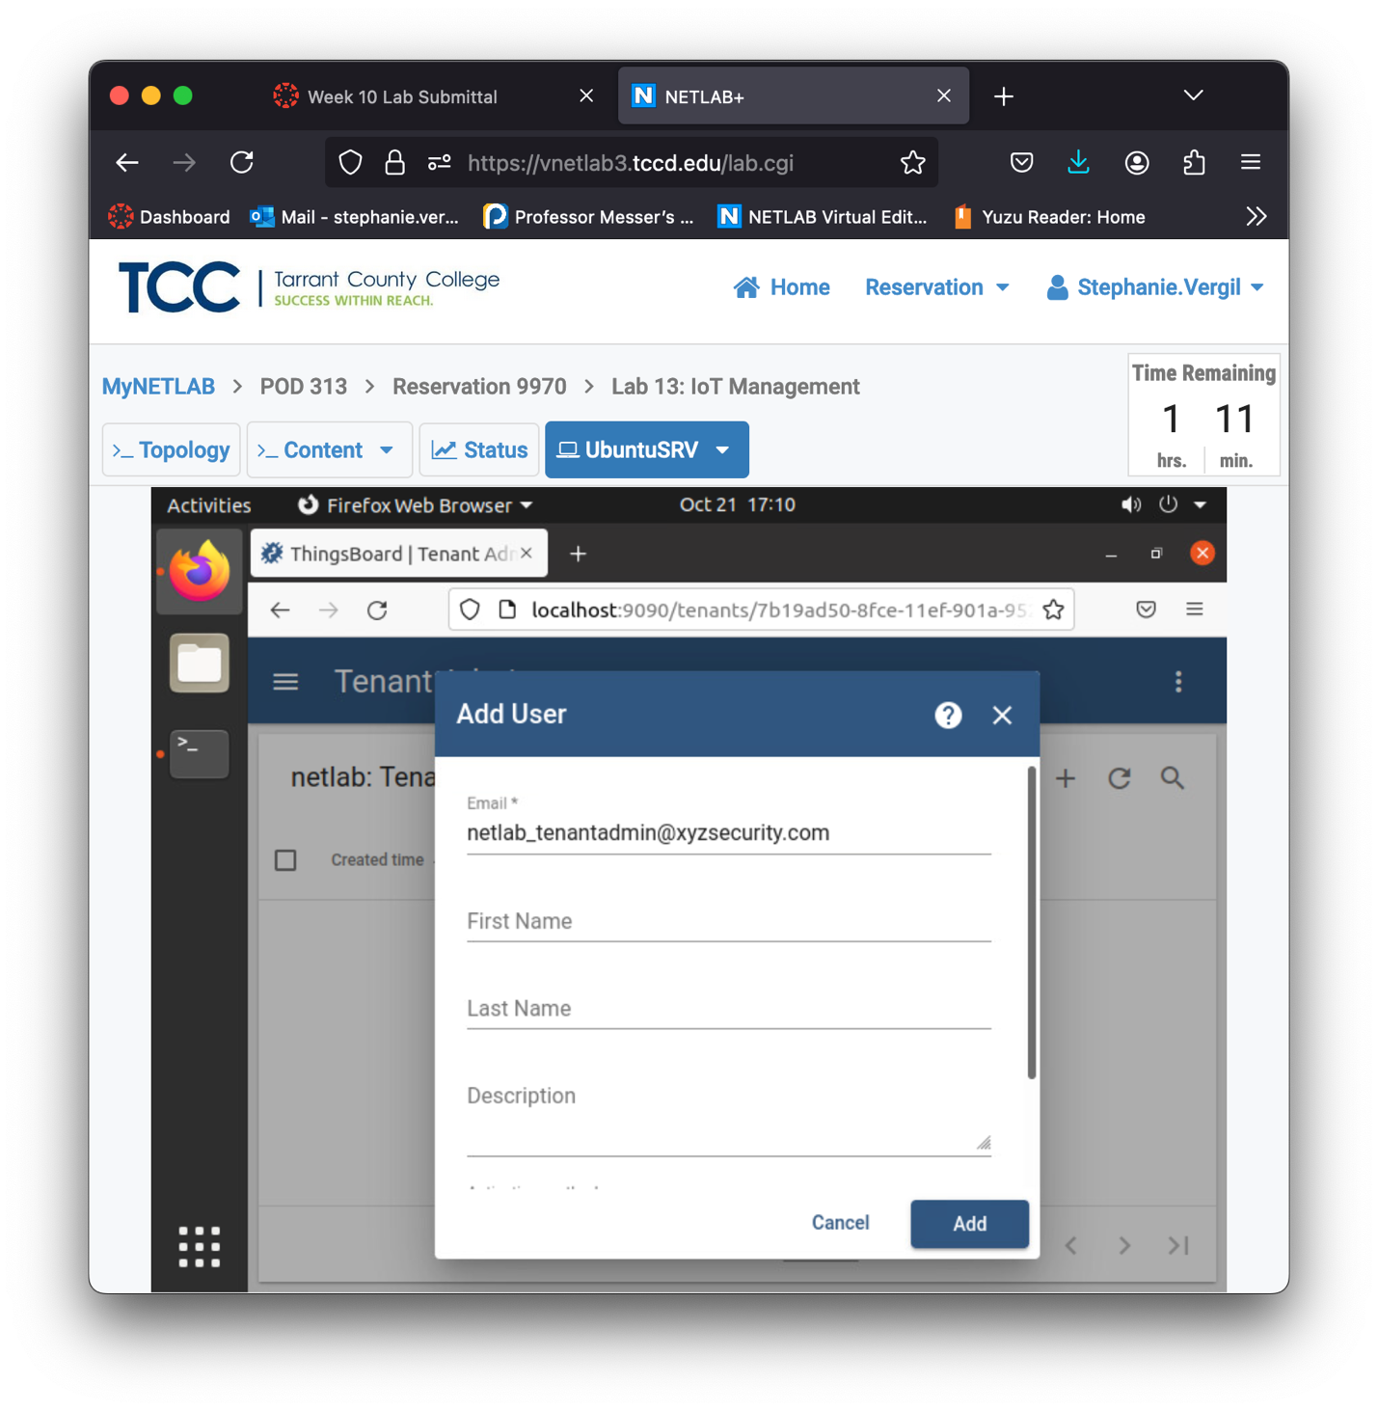

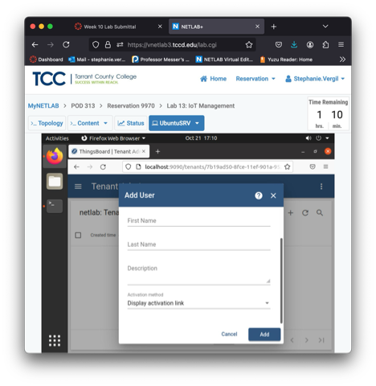

1. After you click the Add button, a new window will show. Click the Copy button to copy the activation link. It will prompt with, User activation link has been copied to clipboard, click Close.

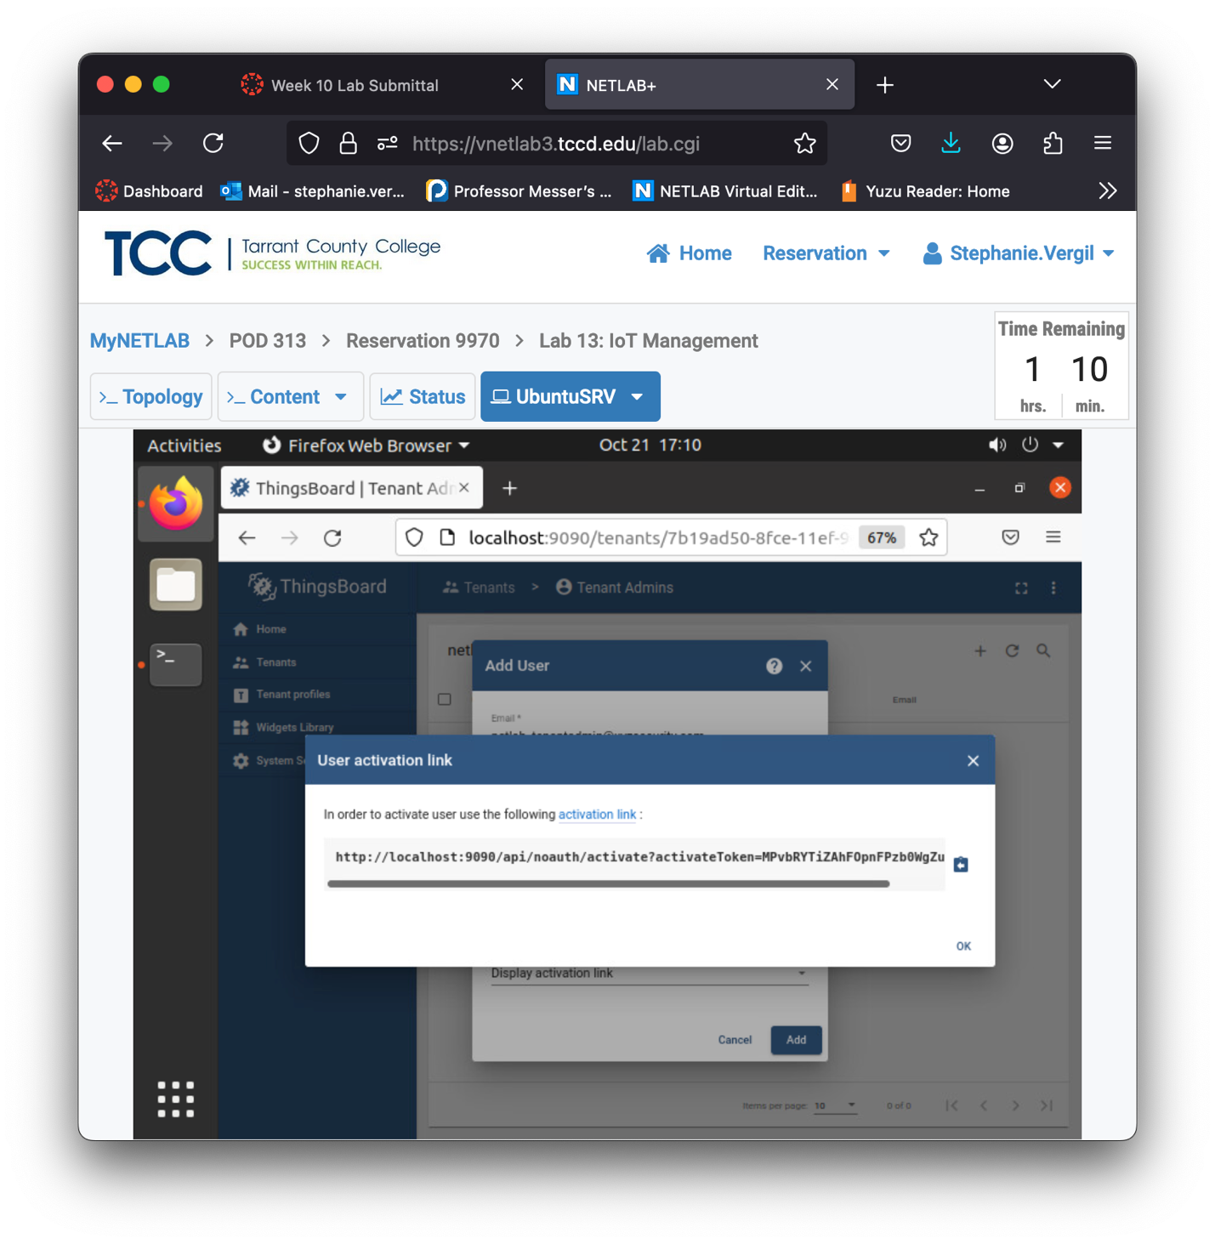

1. Start a new tab in the browser and paste the copied link to the address bar. Press Enter to visit that page.
2. You will be asked to create a password for the account; type NDGlabpass123! Create Password.
3. You will be brought to the main admin page, and the upper-right corner should show that you are logged in as the netlab_tenantadmin@xyzsecurity.com account. To the left side, there will be more options showing than before.

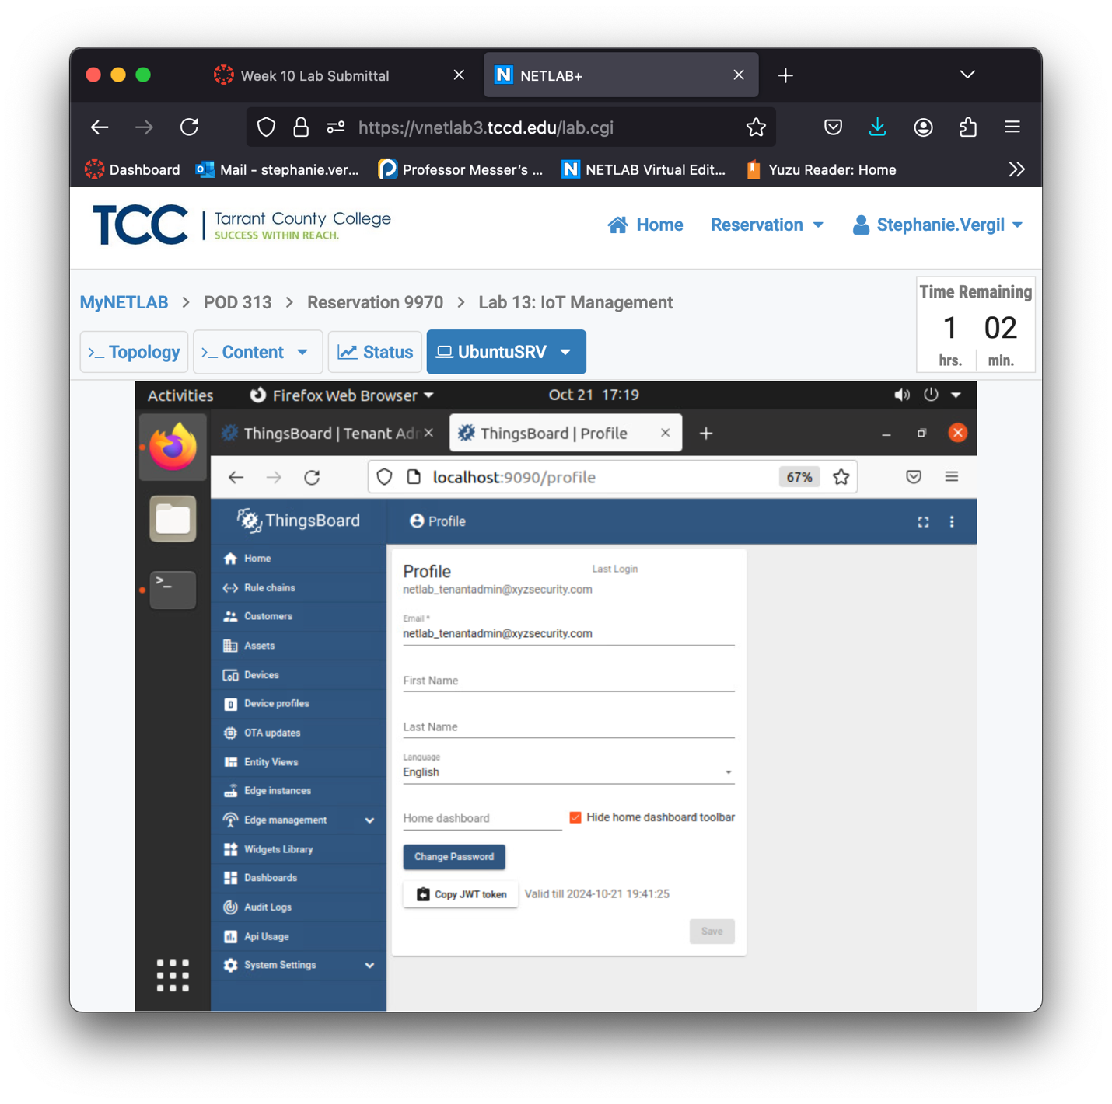

1. Click the Customers button, then on the right side, click the + to add a new customer.
2. In the pop-up window, we will fill the title field with test_customer as our customer and leave the rest blank. Click the Add button.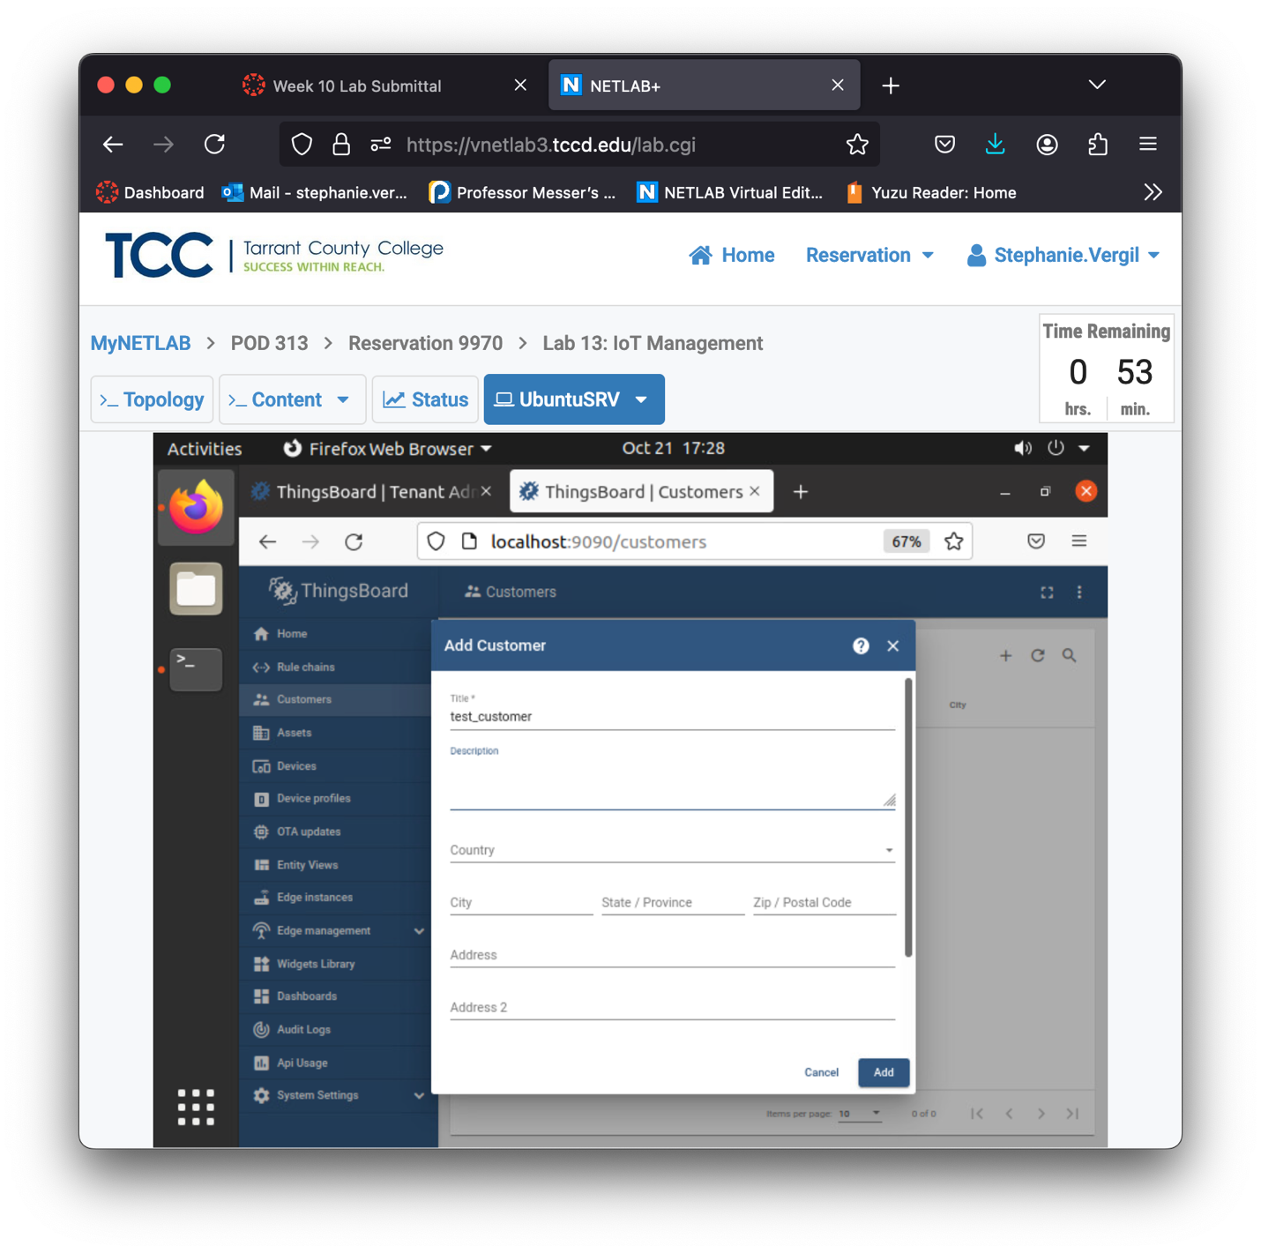
3. The customer should be created and shown on the Customers page. Leave the window open and proceed to the next step.

